**PSG COLLEGE OF TECHNOLOGY, COIMBATORE – 641 004**

**Department of Applied Mathematics and Computational Sciences**

**MSc SOFTWARE SYSTEMS – Semester IV**

**20XW48 – Web Designing Lab**

**PROBLEM SHEET**

**By: Abishek. A**

1. Write a HTML code to use <canvas> element to draw rectangle with different color models.

<html>

    <canvas id="myCanvas" width="600" height="400" border="1px">

    </canvas>

    <script>

**var** c = document.getElementById("myCanvas");

**var** ctx = c.getContext("2d");

        ctx.fillStyle = "#fc6b03";

        ctx.fillRect(20, 20, 300,50);

        ctx.fillStyle="white";

        ctx.fillRect(20,70,300,50);

        ctx.strokeStyle="#000080";

        ctx.beginPath();

        ctx.arc(170, 95, 25, 0, 2 * Math.PI);

        ctx.stroke();

        ctx.fillStyle="green";

        ctx.fillRect(20,120,300,50);

    </script>

</html>

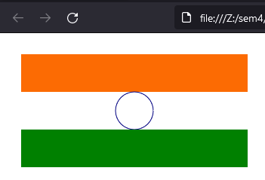

1. Create a page to show the usage of <mark> element in highlighting the contents.

<html>

    <h2><mark>India</mark>, officially the <mark>Republic of India</mark> is a country in South Asia. It is the <mark>seventh</mark>-largest country by area, <mark>the most</mark> populous country in the world.</h2>

</html>

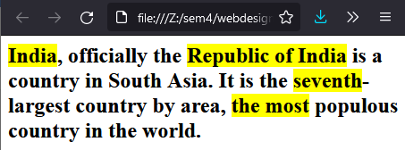

1. Create a simple search form using a search input element in which the user can enter a search query. Using the Firefox web browser, test the form by entering January and submitting the form. Then enter a **J** in the input element to see previous entries that started with J—January should be displayed below the input element. Enter June and submit the form again. Now enter a **J** in the input element to see previous entries that started with J—January and June

Should be displayed below the input element. Try this with your own search queries as well.

<html>

    <form>

        <label for="name">Search Box</label>

        <input type="text" name="name"></input><br><br>

        <input type="date" name="name"></input><br><br>

        <input type="time" name="name"></input></br><br>

        <input type="submit" value="submit"></input>

    </form>

</html>

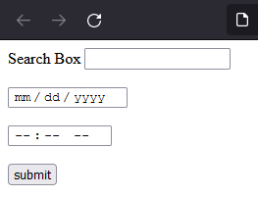

1. Write a HTML file to implement various date picker controls and align the controls in the center of the page.

<html>

<form align="center">

  <div class="nativeDatePicker">

    <label for="bday">Enter your birthday:</label>

    <input type="date" id="bday" name="bday">

    <span class="validity"></span>

  </div>

  <p class="fallbackLabel">Enter your birthday:</p>

  <div class="fallbackDatePicker">

    <span>

      <label for="day">Day:</label>

      <select id="day" name="day">

      </select>

    </span>

    <span>

      <label for="month">Month:</label>

      <select id="month" name="month">

        <option selected>January</option>

        <option>February</option>

        <option>March</option>

        <option>April</option>

        <option>May</option>

        <option>June</option>

        <option>July</option>

        <option>August</option>

        <option>September</option>

        <option>October</option>

        <option>November</option>

        <option>December</option>

      </select>

    </span>

    <span>

      <label for="year">Year:</label>

      <select id="year" name="year">

      </select>

    </span>

<br>

<br>

<label for="start">Start date:</label>

<input type="date" id="start" name="trip-start"

       value="2018-07-22"

       min="2018-01-01" max="2018-12-31">

<p>(To set date limits)</p>

<br>

<label>

    Schedule:

    <input type="date" name="office" min="2017-04-01" max="2017-04-20" required>

    <span class="validity"></span>

</label>

<p>(Check validity)</p>

<br>

<label>Enter your birthday:

    <input type="date" name="bday" required pattern="\d{4}-\d{2}-\d{2}">

    <span class="validity"></span>

  </label>

  </div>

</form>

</html>

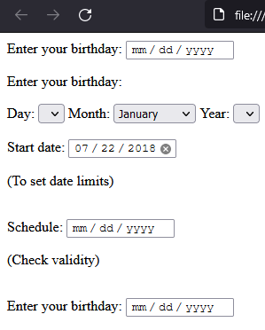

1. Using <iframe> and split the page into multiple sections and set the sources. One of section in the page should restrict plugins and scripts.

<html>

    <center>

    <table border="1">

        <tr>

            <td>

                <a href="https://www.psgtech.edu/" target="view"><button>PSGCT</button></a>

                <br><a href="https://www.iitm.ac.in/" target="view"><button>IITM</button></a>

                <br><a href="http://www.psgitech.ac.in/" target="view"><button>PSGIT</button></a>

            </td>

            <td>

                <iframe src="https://www.psgtech.edu/" name="view" width="500px" height="500px" style="border:5px solid black;">

                </iframe>

            </td>

        </tr>

</html>



1. Design a web page to render different 2D Graphics objects (Circle, Rectangle, Line, Ellipse, Polygon, Polyline and Gradients).

<html>

    <canvas id="myCanvas" width="1000" height="1000">

    </canvas>

    <script>

**var** c = document.getElementById("myCanvas");

**var** ctx = c.getContext("2d");

        ctx.fillStyle = "Green";

        ctx.fillRect(20, 20, 100, 70);

        ctx.beginPath();

        ctx.fillStyle = "Red";

        ctx.moveTo(150, 60);

        ctx.lineTo(100, 75);

        ctx.lineTo(150, 25);

        ctx.fill();

        ctx.beginPath();

        ctx.ellipse(75, 100, 20, 30, Math.PI / 2, 0, 2 * Math.PI);

        ctx.stroke();

        ctx.fill();

        ctx.fillStyle = "orange";

        ctx.beginPath();

        ctx.moveTo(10, 200);

        ctx.lineTo(150,250);

        ctx.lineTo(100, 300);

        ctx.lineTo(10, 290);

        ctx.closePath();

        ctx.fill();

        ctx.lineWidth = 1.5;

        ctx.strokeStyle = 'red';

        ctx.beginPath();

**var** y=350;

        for (**var** i = 0; i < 45; i++)

        {

**var** x = Math.random() * 100;

                ctx.lineTo(x, y);

                y=350+x;

        }

        ctx.stroke();

**var** grd = ctx.createLinearGradient(0, 0, 200, 0);

        grd.addColorStop(0, "red");

        grd.addColorStop(1, "white");

*// Fill with gradient*

        ctx.fillStyle = grd;

        ctx.fillRect(100, 100, 150, 80);

    </script>

<html>

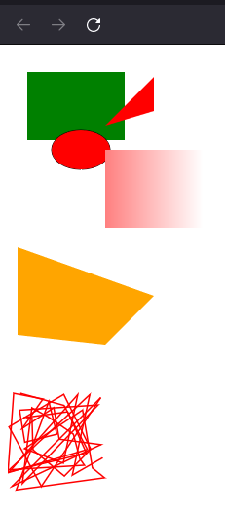

1. Design a web page for audio album list to play different types audio files.

<html>

    <p>claps</p>

    <audio controls>

        <source src="clap.mp3" type="audio/mpeg">

    </audio>

</html>

